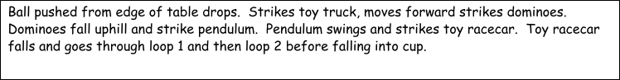
Student Name: _____________________________ Bell: ______
Energy Unit Alternate Assessment Version 1
Formulas
Eg = mgh =Ek= ½ mv² = W= Fxd
M (10 m/s/s) h = ½ mv² = ma x d
Ek= ½ mv² rearranged to solve for v looks like this:

= $\sqrt{\frac{2E_{k}}{M}}$ = $\sqrt{V^{2}}$ Which becomes $\sqrt{\frac{2E_{k}}{M}}$ = v

If you don’t know how to take a square root, then2 solve one side of the equation and leave the other side as
Remember that h or d must be converted from cm to m
Example 15.3 cm ÷ 100 = 0.153 m OR mathematically $\frac{15.3 cm}{1}$ × $\frac{1 cm}{100 cm}$ = 0. 153 𝑚
You need to use the measurements with each section of problems to answer/solve them. You must show ALL work, with units. If you choose to make a copy of this Google Doc and type the answers that is fine or you can choose to work on notebook paper or a whiteboard, take a clear photo of the work and upload it to the appropriate location in the Google Doc.
Please, give yourself plenty of time, so that you can show that you have mastered this skill set.
There is a different Rube Goldberg Machine for each problem set. Best of Luck!

Machine # 1
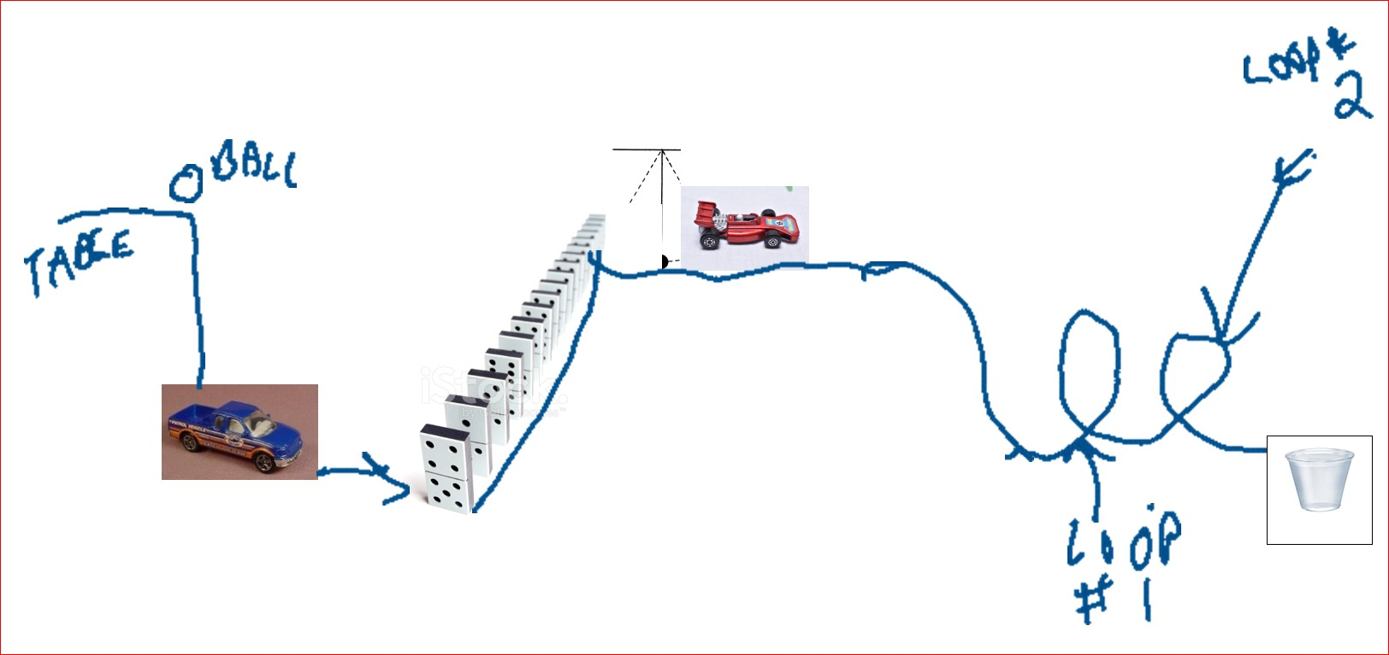
Measurements are listed here:
Height of golf ball on table to where it hits toy truck is 40.0 cm Mass of golf ball is 0.04593 kg Distance truck moves to reach dominoes is 6.0 cm Mass of toy truck is 0.114 kg
- (8 points) Compute the Eg for the golf ball.
Solution
E_{g}= mgh = mass of the golf ball x gravitational acceleration x height of the ball
Mass of the ball=0.04593kg,
Gravity acceleration =10ms-2
Height=40cm= 0.4m
Substituting these values, we have:
E_{g}= mgh =0.04593kg x10 x$\frac{40}{100}$m
= 0.18372J
- (8 points) Compute the velocity for the toy pick-up truck using your knowledge of Ek and Eg.
Solution
E_{g}=E_{k}=$\frac{1}{2}$ mv²
Mgh=$\frac{1}{2}mv$²
E_{g} ball= $\frac{1}{2}mv$² (conservation of energy)
=$\frac{1}{2}$ x 0.114 x V² = 0.18372
V² = $\frac{0.18372 x 2}{0.114}$
= 3.2232
v=$\sqrt{3.2232}$
V=1.7953 m/s

- (8 points) What work did the truck do? (You must give an explanation and a numerical answer with the units to earn all the points.)
Solution
E_{g} = mgh =Ek= ½ mv²=W= Fxd
E_{g}ball = $\frac{1}{2}$ (mass of truck) x (velocity of truck)² = work done by the truck (W)
E_{g}ball = 0.18372
mass of truck= 0.114kg
velocity of truck= 1.7953 m/s
W= $\frac{1}{2}$ x 0.114 x (1.7953)² = E_{g}ball = 0.18372 Joules
Work done by the truck (W) =0.18023Joules
- (3 points) Draw the energy bar chart for when the ball is ½ way through its fall.
Solution
When the ball is at the top; mgh=o since it is at rest at this point
When the ball is $\frac{1}{2}$ way fall; the height is $\frac{1}{2}$ (40cm) =20cm
Mass of the ball=0.04593kg
Eg= mass the ball x g x $\frac{1}{2}$ (40cm)
Eg= 0.04593 x 10 x $\frac{1}{2}$ (0.4) =0.09186 Joules

(X 10⁻²)
joules

Height (cm)

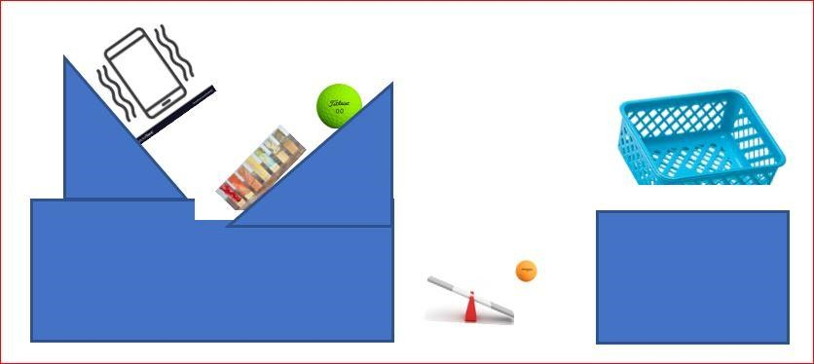
Machine # 2

Measurements are listed here:
Height of cell phone to Jenga blocks is 15.0 cm Mass of cell phone is 0.138 kg
Distance the golf ball falls is 56.0 cm Mass of golf ball is 0.04593 kg
Height of ping pong ball to the blue basket is 33.0 cm Mass of ping pong 0.0027 kg

- (8 points) Compute the Eg for the ping pong ball.
Solution
Egball = mgh
M=mass of the ball =0.0027 kg
g=10mls2,
h= height the ball fall = 33cm = 0.33m
substituting,
Mgh = 0.0027 x 10 x 0.33 = 0.00891J
- (8 points) Compute the velocity for the golf ball using your knowledge of Ek and Eg.

Solution
Eg = Ek = mgh = $\frac{1}{2}$mv2
Eg= $\frac{1}{2}$mv2
where:
v= velocity of the golf ball, and
m= mass of the golf ball = 0.04593 kg
Therefore;
Mgh = 0.04593 x 10 x 0.56 = $\frac{1}{2}$ x 0.04593 x v²
= 0.2572 = $\frac{1}{2}$ x 0.04593 x v²
V²= $\frac{0.2572 x 2}{0.04593}$ =1.11997
V= $\sqrt{1.11997}$
V= 1.0583 m/s

- (8 points) What work did the golf ball do? (You must give an explanation and a numerical answer with the units to earn all of the points.)
Solution
Work done by the golf ball = $\frac{1}{2}$ mv2
Where:
m= mass of the golf ball = 0.04593 kg
v= velocity of the golf ball v= 1.0583mls

W= $\frac{1}{2}$ x 0.04593 x (1.0583)²
W= 0.0258 Joules

4. (3 points) Draw the energy bar chart for the position of the ping pong ball as shown in the image.

Machine # 3
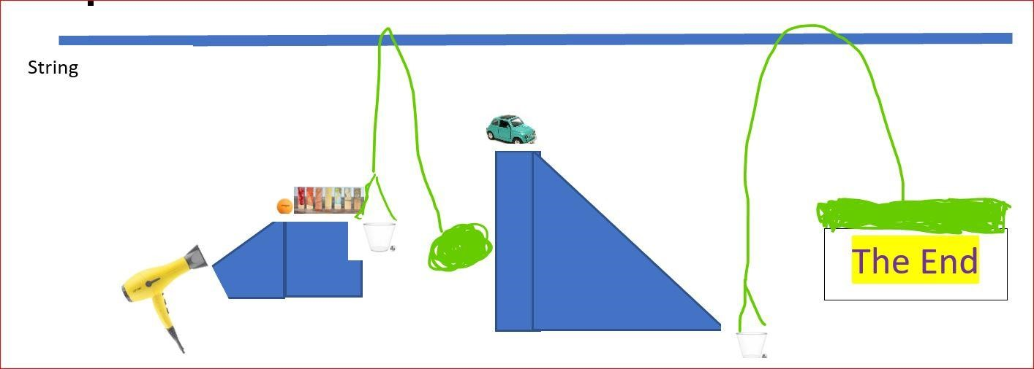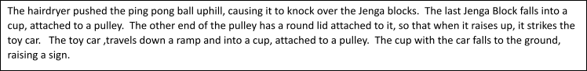
Measurements are listed here:
Height of Jenga and cup to ground is 50.5 cm Mass of Jenga is 0.0107 kg Mass of cup is 0.00853 kg
Distance the car and cup falls is 72.4 cm Mass of toy car is 0.038 kg Mass of cup is 0.00853 kg
Distance the sign moves is 72.4 cm Mass of the sign is 0.09 kg

- (8 points) Compute the Eg for the Jenga and cup.
Solution
Eg for the Jenga
Eg=mgh
Where:
M=mass of Jenga = 0.0107 kg,
g= gravitional acceleration= 10m/s²
h= height of Jenga to the ground= 50.5cm = 0.505m
Eg for the Jenga= Mass of Jenga x gravitional acceleration (g) x height
Mgh=0.0107 x 0.505 x 10 = 0.054035 J

Eg for the cup = mgh
Where:
m= mass of the jenga cup=0.00853kg
g= gravitational acceleration =10m/s²
h= height =50.5cm=0.505m

Eg = 0.00853 kg x 10 x 0.505
= 0.0430765 J

- (8 points) Compute the velocity for the sign, using your knowledge of Ek and Eg.
Solution
Eg = Ek= mgh = $\frac{1}{2}$ mv2
Eg =mgh
Where:
m= mass of sign=0.09kg
g=gravitional acceleration =10m/s²
h=height = 72.4cm = 0.724m

Eg= 0.09 x 10 x 0.724 = 0.6516
Eg = mgh = $\frac{1}{2}$ mv²= 0.6516
$\frac{1}{2}$ x 0.09 V²= 0.6516
V² = 14.48
V=$\sqrt{14.48}$
=3.8053mls
- (8 points) What work did the golf ball do? (You must give an explanation and a numerical answer with the units to earn all of the points.)
Solution
Work done by the golf ball (w)= Eg for the Jenga = mass of Jenga x gravitational acceleration x height of Jenga
W=E_{g}=mgh
M=0.0107kg,
g=10m/s²
h= 50.5cm=0.505m
W= Eg=mgh= 0.0107 x 10 x 0.505=0.054035
W= 0.054035Joules
- (4 points) Draw the energy bar chart for the ping pong when it is half-way up the ramp and don’t forget to include the types of energy associated with the hair dryer.
Solution
The half-height = $\frac{1}{2}$x 50.5cm =25.25cm=0.2525m
Eg of Ping Pong ball at half height = 0.0107 x 10 x 0.2525
= 0.0270 Joules

